School visitor lunch

At Let’s Dine we are committed to ensure that we are meeting your needs with regard to allergen information, to ensure we have the correct information if you are having lunch in school could I please ask you to complete the below form identifying any allergies or special dietary requirements and return the slip to the school office before having lunch.

Kind Regards

Lorna
Catering Group Manger (Let’s Dine)

Name: ________________________________________________

Please tick any allergens from the list below or state underneath any other allergens/intolerances or cultural requirements

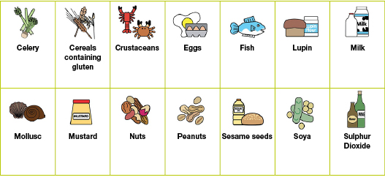

Vegetarian

Any other intolerances/allergies/Cultural Requirements:

______________________________________________________________________________

––––––––––––––––––––––––––––––––––––––––––––––––––––––––––––––––––––––––––––––

Signature: _____________________________________________

